MIGRATE-XX
Title of the paper. please replace Above “XX” with the reference number of your abstract. Centered, 14 Point, Capital Bold, "Title" style
First Name1 LastName1¹, First Name2 LastName2*, First Name3 LastName3²
¹Mailing address12
firstname.name@firm.country1, firstname.name@firm.country2
²Mailing address3
firstname.name@firm.country3

KEY WORDS
Place here a list of significant key words separated by commas. Avoid repeating words already mentioned in the title of the paper.

Abstract
Place here a 200-250 word abstract. Use 10 point Times New Roman ("Abstract" Style) here and throughout the main text below. The abstract must summarize the context of the study and emphasize its main outcomes and new results. Write the abstract in block style and do not divide it into several paragraphs.

1. introduction, First headings
This is the template file for preparing full-length manuscripts. You are requested to follow closely the following instructions. Do not skip a line before or after the first headings, this is taken care of by first heading style (Titre 1; Heading 1, MS Word shortcut: CRTL+SHIFT+1). If you do not use Windows Word Styles, use Times New Roman, 12 Point, Capital, Bold, flush left and skip two lines before and one after the heading. Do not indent the first line of the paragraph following immediately the heading.

The manuscript should be typewritten in a single column using Times New Roman font, on the A4-sized sheets with the left and right margins set to 2 cm and top and bottom margins set respectively to 1.7 cm and 2 cm. It is recommended that the number of pages should not exceed 10 pages and the size of the electronic file should not exceed 1.5 MB after conversion to the PDF format. Large pdf files are generally encoutered if too many high resolution images are included in the text. If your pdf file exceeds the limit size, consider downgrading the images resolution.
The author is responsible for the quality of the pdf conversion. Paper sent in Windows Word or rtf format will be converted to pdf with no guarantee on the result. Using Adode PDF Writer or Acrobat Distiller (version 5 or earlier) as a printer is a good choice provided that you tick the appropriate options regarding the embedding of non-standard fonts.

The text should be typewritten with single spacing throughout the manuscript. The article should be logically divided into sections and subsections with Arabic numbering. The second level headings (subsection titles) should be 11 point, bold, flush left, and with capital letters for the first letters of words. This is automatically done if you use the "second heading" style (Titre2; Heading 2, MS Word shortcut: CTRL+SHIFT+2). The third level headings should be 11 point, italic and flush left. This is automatically done if you use the third heading style (Titre 3; Heading 3, MS Word shortcut: CTRL+SHIFT+3). Do not use more than three levels of headings.

A blank line must be used to divide paragraphs, indent the first lines of paragraphs by 7.5 mm tab as it is done in this template provided that the new paragraph does not follow immediately a heading. Please do not place blank lines at the top of a page. In addition, do not place the headings at the bottom of pages.

Affiliation
Author’s names and affiliations may be mentioned using the proposed "affiliation" style described above. Please indicate with a Footnote the corresponding Author.

2. Second and Subsequent Major Headings
If text separates two headings, the spacing is taken care of by the style of the heading.

2.1 Secondary Title or Subsection
Secondary titles should start flush left (Titre2 Heading 2 style ; CTRL+SHIFT+2). Text following a subtitle is placed here automatically when "Normal" style is used throughout the text for plain paragraphs.

3. NEXT HEADINGS

3.1 Secondary Title or Subsection
If no text separates two headings, the spacing is taken care of by the style of the heading. Text following a subtitle is placed here automatically when "Normal" style is used throughout the text for plain paragraphs.

3.1.1 Subsection
If further subdivision of the text is needed use the "third heading" style: Italic, 11 Point, flush left, skip a 6 point space before and after the heading.

4. Formulas
Equations should be centered and should be numbered consecutively using Arabic numbers in parentheses in the right hand margin. This is automatically done if you use the appropriate style (Centered Formula) which provides a centered tab for the formula and flushed right tab for the equation number:
, (1)
where denotes the steam quality, is the equilibrium quality and is a relaxation time. Blank lines should not be placed before and after the equation(s) if the same paragraph is continued. Please define all the variables immediately after their first occurrence in the text as shown for Eq.(1). Refer to an equation by using its number enclosed by parentheses.

5. Tables and Figures
All Figures and Tables must be referenced in the text and the captions should be flush left or may be centered below the figure or the table if it is less than one line long. The word Table or Figure must be printed in bold style. Use a single blank line after and before figures or tables. They may also be included with their caption in an array with one line and one column. In this case do not allow the splitting of cells on different pages. This procedure allows a simpler placement of the Figures and Tables with their caption in the text. You should refer in the text to each table and figure as Fig.1 or Tab.1.
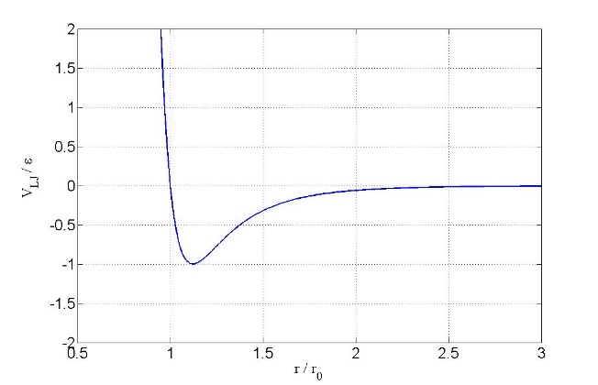

Figure 1: Example figure. Color can be used.

Experiment | Length, (m) | Velocity, (m/s) | Temperature, (K)
Case 1 | 1.0 | 2.50 | 300
Case 2 | 10. | 1.50 | 320
Case 3a | 5 | 10.0 | 300
Case 3b | 5 | 10.0 | 400

Table 1: Example table. Experiments nomenclature

When importing Figures or any other image, make sure of two things: (a) any number, text or symbol is in Times font and is not smaller than 10-point after reduction to the actual window in your paper; (b) it can be printed in Postscript by Windows Word.

5. CONCLUSIONS
Present your summary and conclusions here.

NOMENCLATURE
Summarize nomenclature here. Nomenclature should conform to that most frequently used in the engineering field concerned. Nomenclature should contain reference to the definition equations invoked in the text such as those of the non-dimensional numbers. A nomenclature section may not be needed if care is taken to define all the variables after their first occurrence in the text.

ACKNOWLEDGEMENTS
Acknowledge the help of colleagues, and sources of funding, if any.

REFERENCES and Citations
References to published literature should be quoted in the text by enclosing between two brackets the number of the reference. Please refer to the following examples:

[1] Collier, J. G., & Thome, J. R. (1994). Convective boiling and condensation. third edn. Oxford: Clarendon Press.
[2] Delhaye, J. M., Giot, M., & Riethmuller, M. L. (1981). Thermal-hydraulics of two-phase systems for industrial design and nuclear engineering. Hemisphere and McGraw Hill.
[3] Lamb, H. (1932). Hydrodynamics. Cambridge University Press.
[4] Zwick, S. A., & Plesset, M. S. (1954). On the dynamics of small vapor bubbles in liquid. J. Math. Phys, 33, 308-330.

Using the appropriate style for the references [RefBiblioNomDate] standardizes the indentation of the paragraphs and avoids the splitting of the references by the end of a page. References must be placed at the end of the paper.

* Corresponding author

